HIV Project

Student Assignment Learning Outcomes:
- The learner will analyze statistical data from the Center for Disease Control (CDC) and interpret its statistical significance.
- Utilizing the statistical data, the learner will create nursing interventions at local and global health care levels to support the Health People 2020 goal to prevent HIV infection and its illnesses.
Background:
Human Immunodeficiency Virus (HIV) is a virus transmitted through blood an/or body fluid exposure. HIV may lead to Acquired Immunodeficiency Syndrome or AIDs.
At this time, there is no cure for HIV or AIDs. However, with appropriate healthcare, HIV can be controlled. The primary medical treatment for HIV is the administration of antiretroviral drug therapy (called HAART). Nursing interventions for HIV include a holistic approach to address the physical, emotional, psychosocial and spiritual needs of the client to promote health and well-being.
HIV attacks the CD4 cells or T-cells of the human immune system. The virus infects a CD4 cell; then utilizes the DNA of the CD4 cells to replicate. This replication process destroys these CD4 cells so they are unable to function appropriately as a immune cell. As the CD4 cell number decreases, the client’s immune system’s ability to fight infection is decreased, which increases their risk for opportunistic infections or cancers. When the CD4 count decreases below 500, the individual is categoriszed as having AIDs.
“The CDC disease staging system (most recently revised in 1993) assesses the severity of HIV disease by CD4 cell counts and by the presence of specific HIV-related conditions. The definition of AIDS includes all HIV-infected individuals with CD4 counts of <200 cells/µL (or CD4 percentage <14%) as well as those with certain HIV-related conditions and symptoms” (retrieved on June 3, 2016 from http://aidsetc.org/guide/hiv-classification-cdc-and-who-staging-systems). Further exploration of the specific CDC classification system for HIV in adults and adolescents may also be accessed at this web link.
“The HIV epidemic in the United States continues to be a major public health crisis. An estimated 1.1 million Americans are living with HIV, and 1 out of 5 people with HIV do not know they have it. HIV continues to spread, leading to about 56,000 new HIV infections each year” (retrieved on June 4, 2016 from https://www.healthypeople.gov/2020/topics-objectives/topic/hiv) . As HIV has continued to be a health care issue, one of the goals of Health People 2020 is to “Prevent HIV infections and its related illness and death”. (retrieved on June 4, 2016 from https://www.healthypeople.gov/2020/topics-objectives/topic/hiv) .
Therefore, in this assignment, we will explore the statistical data related to HIV and AIDs cases, interpret this data, and create nursing interventions that can help support the Health People 2020 goal related to HIV, at both a local and global level.

1. Please review the following HIV Diagnoses by transmission categories and interpret the CDC data by answering the questions:
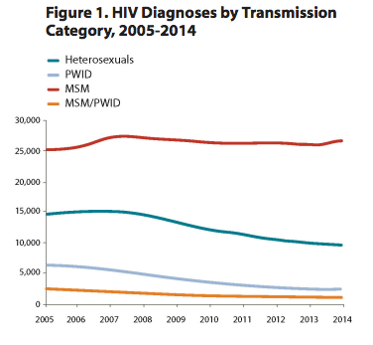
(retrieved on June 3, 2016 from http://www.cdc.gov/nchhstp/newsroom/docs/factsheets/hiv-data-trends-fact-sheet-508.pdf).
- In the past 10 years, which transmission category is at the highest risk for HIV diagnoses?

- How would you interpret the transmission rate of heterosexuals in the past five years?

c) Describe two nursing interventions that would specifically address the trend in HIV transmission as demonstrated in this graph.

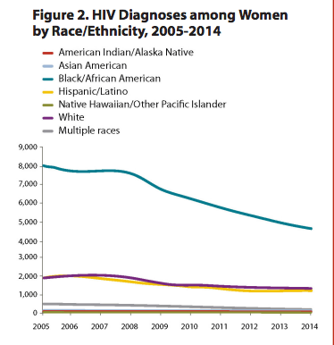
(retrieved on June 3, 2016 from http://www.cdc.gov/nchhstp/newsroom/docs/factsheets/hiv-data-trends-fact-sheet-508.pdf).
- Based on the statistical data graph above, how would you analyze this data in relation to the transmission of HIV in women according to race/ethicnity?

- How would you analyze the health care disparity as shown in the graph above?

- Please develop two nursing public health interventions to address the health care disparity.

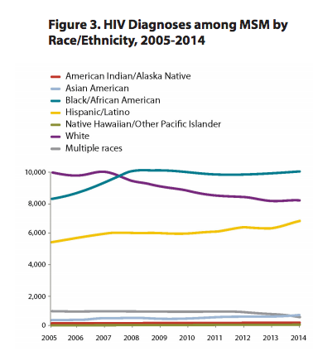
retrieved on June 3, 2016 from http://www.cdc.gov/nchhstp/newsroom/docs/factsheets/hiv-data-trends-fact-sheet-508.pdf).

- How do you interpret the Figure 3 graphic above ? Please describe the statistical data trends for the past 5 years in the diagnoses of HIV in MSM in relation to race / ethnicity utilizing the data in Figure 3.

- Please list three assessment questions that a nurse should ask to assess the sexual history of a male client.

- Describe two nursing interventions to implement to decrease HIV transmission in the highest risk population as demonstrated in Figure 3.

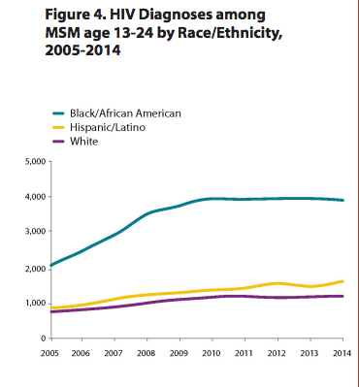
retrieved on June 3, 2016 from http://www.cdc.gov/nchhstp/newsroom/docs/factsheets/hiv-data-trends-fact-sheet-508.pdf).
- How would you interpret the graph above as it pertains to potential health care disparities in relation to race/ethnicity?

- Describe two specific nursing interventions that could be developed and implemented to address the needs of this racial/ethnic group.

Resources for the Assignment:
- Please access this Health People 2020 site to review the HIV goal and overview information: https://www.healthypeople.gov/2020/topics-objectives/topic/hiv
- CDC website: http://www.cdc.gov/hiv/statistics/overview/ataglance.html

